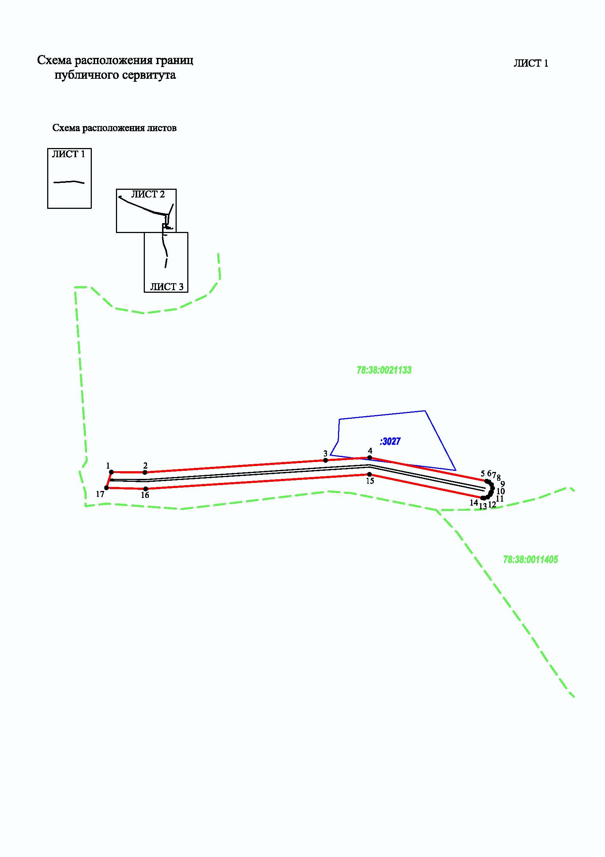

Приложение №1

к распоряжению Комитета имущественных отношений

Санкт-Петербурга

от_____________20 г. N________

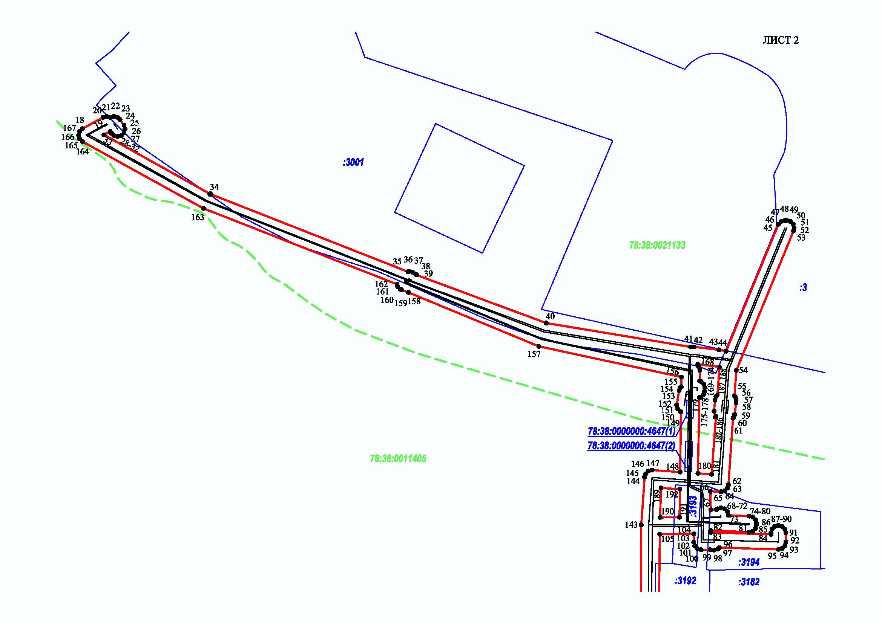

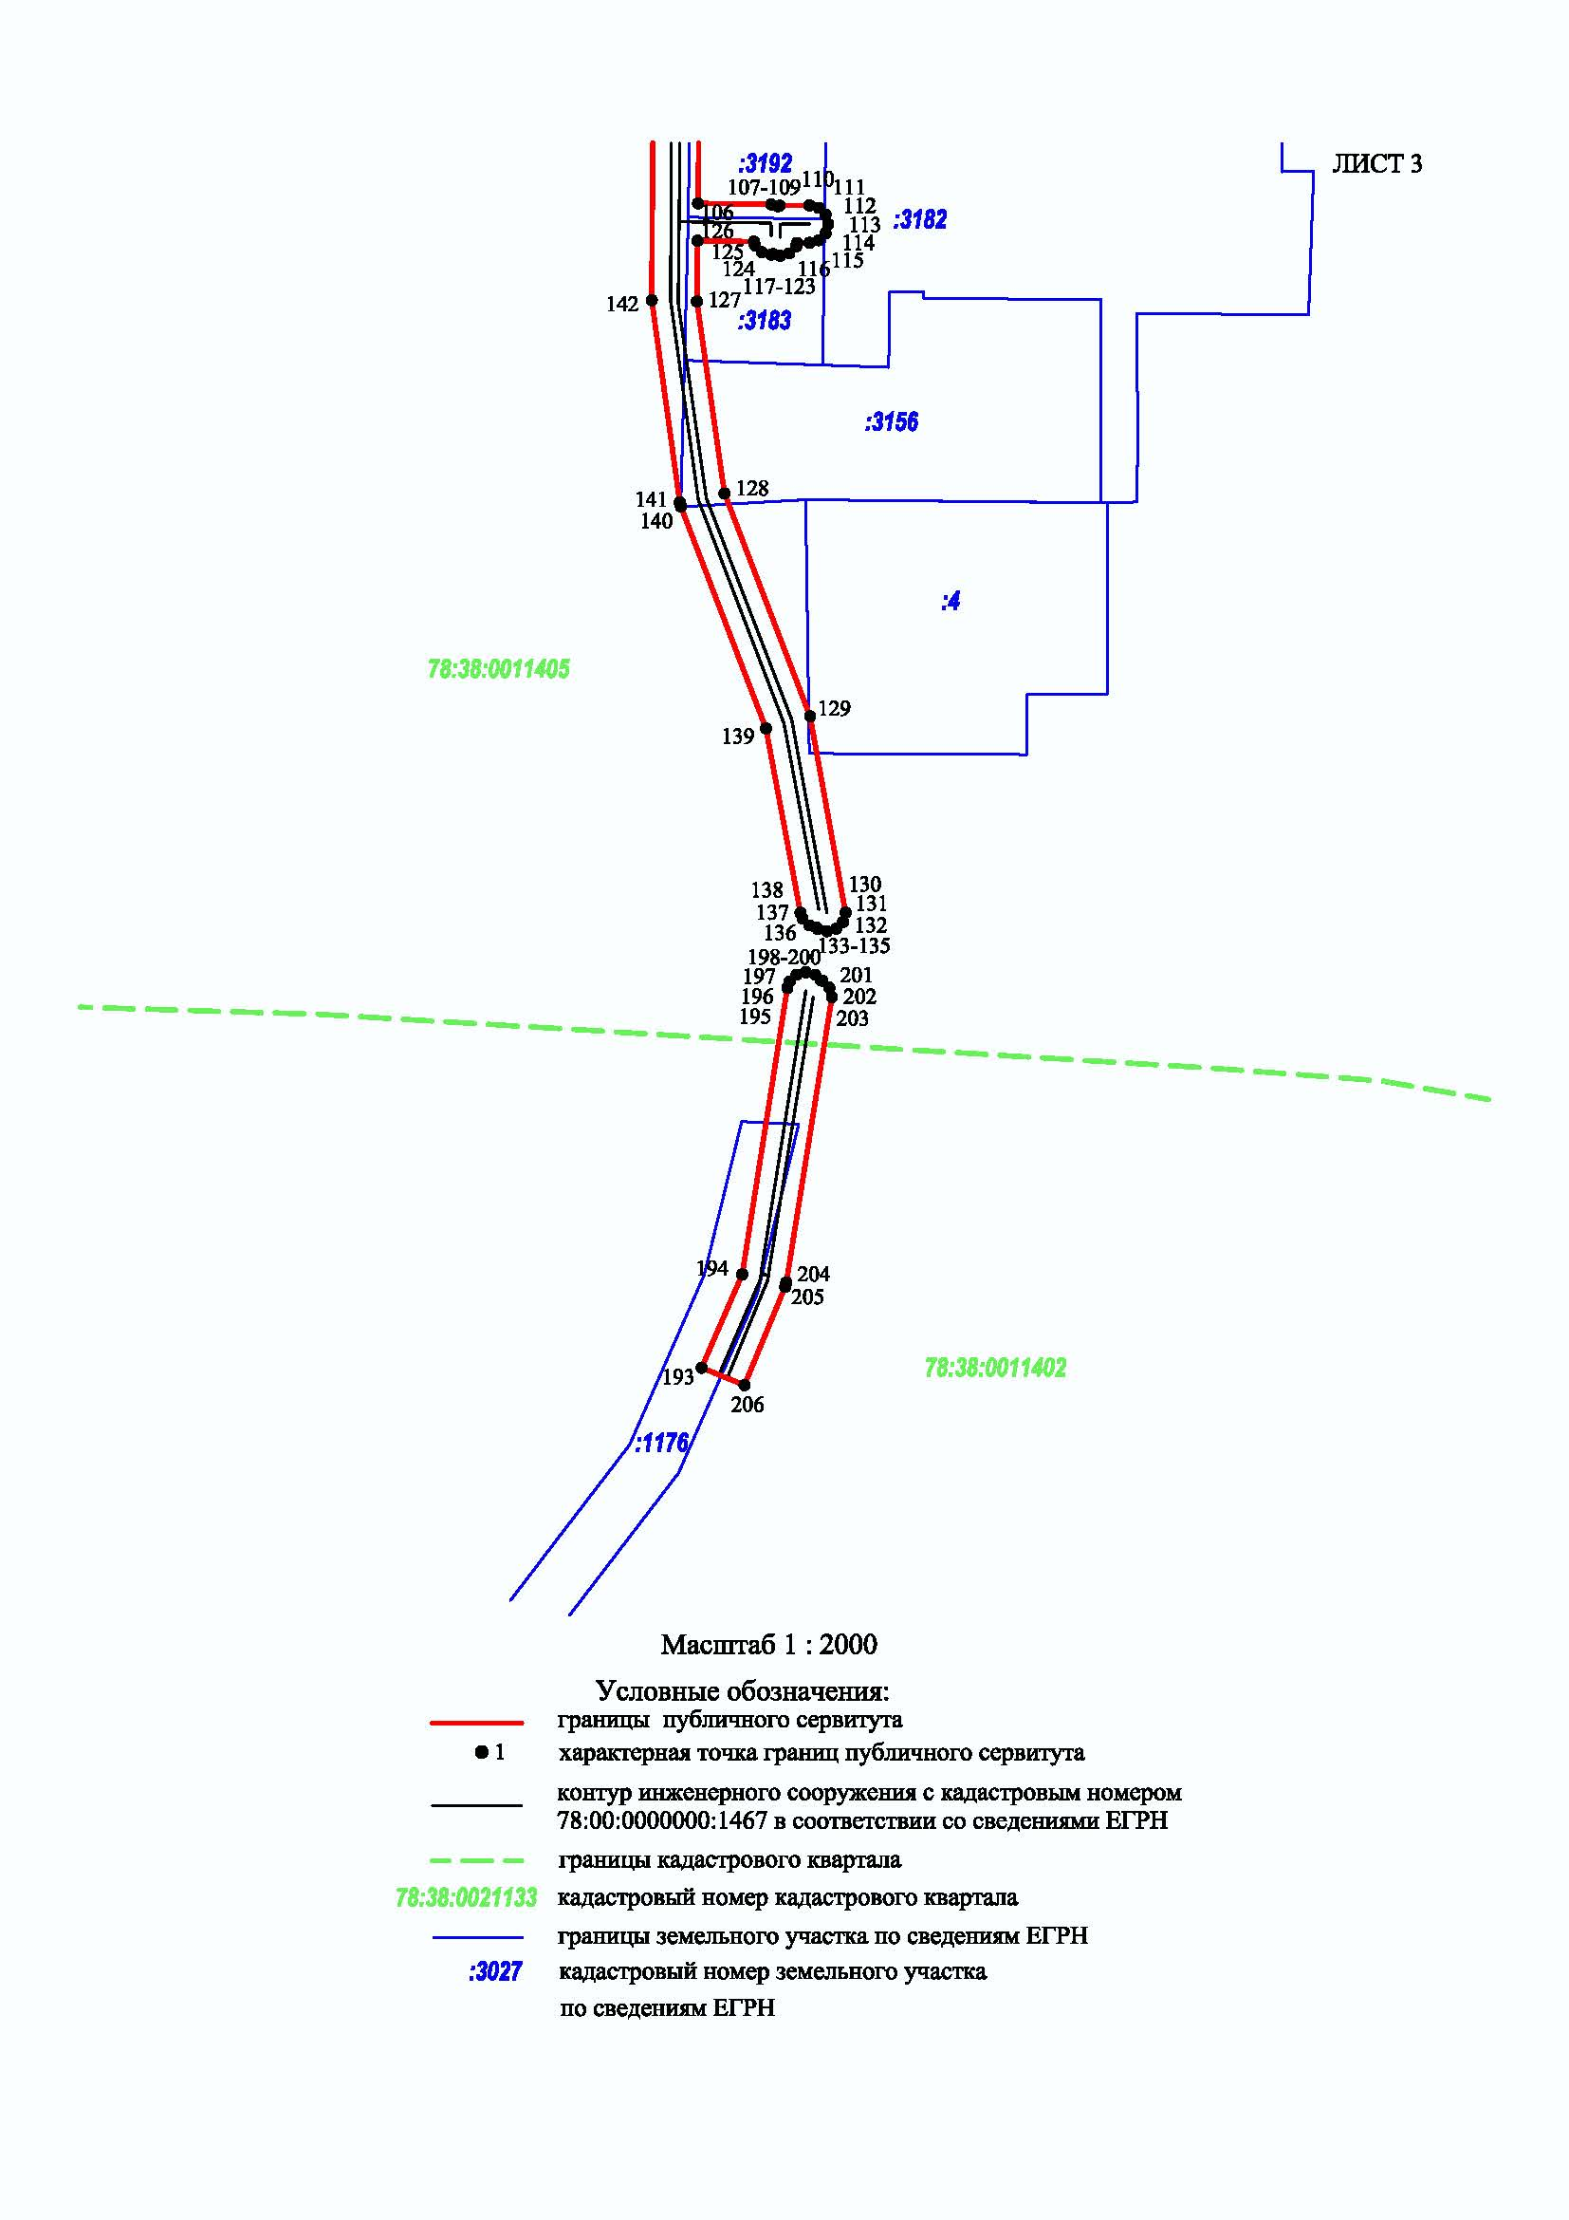

Приложение №2

к распоряжению Комитета имущественных отношений

Санкт-Петербурга

от_____________20 г. N________

|  |  |  |
| --- | --- | --- |
| Обозначение характерных точек границ | Координаты, м | |
| X | Y |
| **1** | **2** | **3** |
| 1 | 115676.95 | 93155.09 |
| 2 | 115676.73 | 93178.39 |
| 3 | 115685.13 | 93303.80 |
| 4 | 115687.01 | 93334.39 |
| 5 | 115670.68 | 93415.71 |
| 6 | 115670.11 | 93417.22 |
| 7 | 115668.28 | 93419.05 |
| 8 | 115665.78 | 93419.72 |
| 9 | 115663.28 | 93419.05 |
| 10 | 115662.78 | 93418.55 |
| 11 | 115661.40 | 93418.18 |
| 12 | 115659.57 | 93416.35 |
| 13 | 115658.90 | 93413.85 |
| 14 | 115659.01 | 93412.83 |
| 15 | 115675.36 | 93334.28 |
| 16 | 115665.31 | 93178.94 |
| 17 | 115666.06 | 93151.67 |
| 1 | 115676.95 | 93155.09 |
| 18 | 115548.87 | 93714.20 |
| 19 | 115556.51 | 93728.12 |
| 20 | 115557.13 | 93730.53 |
| 21 | 115556.49 | 93732.90 |
| 22 | 115557.19 | 93735.43 |
| 23 | 115556.52 | 93737.93 |
| 24 | 115555.06 | 93739.53 |
| 25 | 115551.15 | 93742.24 |
| 26 | 115548.65 | 93742.91 |
| 27 | 115546.15 | 93742.24 |
| 28 | 115544.32 | 93740.41 |
| 29 | 115543.65 | 93737.91 |
| 30 | 115544.32 | 93735.41 |
| 31 | 115545.78 | 93733.82 |
| 32 | 115546.98 | 93732.98 |
| 33 | 115544.77 | 93728.74 |
| 34 | 115504.84 | 93800.26 |
| 35 | 115452.49 | 93933.44 |
| 36 | 115452.71 | 93934.25 |
| 37 | 115452.20 | 93936.53 |
| 38 | 115450.82 | 93938.81 |
| 39 | 115450.26 | 93939.33 |
| 40 | 115417.86 | 94026.66 |
| 41 | 115401.78 | 94123.89 |
| 42 | 115401.81 | 94126.26 |
| 43 | 115399.82 | 94142.96 |
| 44 | 115398.91 | 94147.81 |
| 45 | 115484.44 | 94183.00 |
| 46 | 115486.27 | 94184.83 |
| 47 | 115486.94 | 94187.33 |
| 48 | 115486.82 | 94187.78 |
| 49 | 115487.05 | 94188.64 |
| 50 | 115486.38 | 94191.14 |
| 51 | 115484.55 | 94192.97 |
| 52 | 115482.05 | 94193.64 |
| 53 | 115480.15 | 94193.27 |
| 54 | 115385.97 | 94154.70 |
| 55 | 115368.70 | 94153.44 |
| 56 | 115368.27 | 94153.87 |
| 57 | 115365.96 | 94154.54 |
| 58 | 115364.07 | 94154.54 |
| 59 | 115356.20 | 94153.56 |
| 60 | 115354.32 | 94152.93 |
| 61 | 115353.82 | 94152.43 |
| 62 | 115308.74 | 94149.35 |
| 63 | 115306.58 | 94148.69 |
| 64 | 115304.75 | 94146.86 |
| 65 | 115304.08 | 94144.36 |
| 66 | 115304.48 | 94137.06 |
| 67 | 115291.99 | 94137.47 |
| 68 | 115292.07 | 94141.15 |
| 69 | 115292.63 | 94141.71 |
| 70 | 115293.30 | 94144.21 |
| 71 | 115292.63 | 94146.71 |
| 72 | 115290.80 | 94148.54 |
| 73 | 115288.30 | 94149.21 |
| 74 | 115287.72 | 94163.40 |
| 75 | 115287.05 | 94165.72 |
| 76 | 115285.22 | 94167.55 |
| 77 | 115282.72 | 94168.22 |
| 78 | 115281.87 | 94168.21 |
| 79 | 115279.37 | 94167.54 |
| 80 | 115277.54 | 94165.71 |
| 81 | 115276.87 | 94163.21 |
| 82 | 115278.05 | 94137.43 |
| 83 | 115276.65 | 94137.42 |
| 84 | 115275.42 | 94178.03 |
| 85 | 115276.43 | 94178.03 |
| 86 | 115278.93 | 94178.70 |
| 87 | 115280.76 | 94180.53 |
| 88 | 115281.43 | 94183.03 |
| 89 | 115280.76 | 94185.53 |
| 90 | 115278.93 | 94187.36 |
| 91 | 115276.43 | 94188.03 |
| 92 | 115270.27 | 94188.03 |
| 93 | 115267.77 | 94187.36 |
| 94 | 115265.94 | 94185.53 |
| 95 | 115265.27 | 94183.03 |
| 96 | 115266.46 | 94143.27 |
| 97 | 115265.49 | 94142.30 |
| 98 | 115264.82 | 94139.80 |
| 99 | 115265.04 | 94137.07 |
| 100 | 115265.06 | 94131.00 |
| 101 | 115265.73 | 94128.52 |
| 102 | 115267.56 | 94126.69 |
| 103 | 115270.06 | 94126.02 |
| 104 | 115275.81 | 94126.09 |
| 105 | 115275.52 | 94103.11 |
| 106 | 115221.01 | 94102.51 |
| 107 | 115220.72 | 94122.12 |
| 108 | 115220.26 | 94123.79 |
| 109 | 115220.43 | 94124.43 |
| 110 | 115220.47 | 94132.33 |
| 111 | 115219.80 | 94134.85 |
| 112 | 115217.97 | 94136.68 |
| 113 | 115215.47 | 94137.35 |
| 114 | 115212.97 | 94136.68 |
| 115 | 115211.14 | 94134.85 |
| 116 | 115210.47 | 94132.38 |
| 117 | 115210.45 | 94129.04 |
| 118 | 115209.48 | 94128.78 |
| 119 | 115207.65 | 94126.95 |
| 120 | 115206.98 | 94124.45 |
| 121 | 115207.46 | 94122.65 |
| 122 | 115207.31 | 94122.09 |
| 123 | 115207.98 | 94119.59 |
| 124 | 115209.81 | 94117.76 |
| 125 | 115210.79 | 94117.49 |
| 126 | 115211.01 | 94102.39 |
| 127 | 115194.74 | 94102.21 |
| 128 | 115143.38 | 94109.60 |
| 129 | 115083.74 | 94132.52 |
| 130 | 115031.21 | 94142.01 |
| 131 | 115028.71 | 94141.34 |
| 132 | 115026.88 | 94139.51 |
| 133 | 115026.21 | 94137.01 |
| 134 | 115026.88 | 94134.51 |
| 135 | 115027.30 | 94134.09 |
| 136 | 115027.77 | 94132.34 |
| 137 | 115029.60 | 94130.51 |
| 138 | 115031.18 | 94129.93 |
| 139 | 115080.48 | 94120.70 |
| 140 | 115139.89 | 94097.91 |
| 141 | 115140.99 | 94097.63 |
| 142 | 115195.09 | 94090.15 |
| 143 | 115281.78 | 94090.62 |
| 144 | 115314.09 | 94092.94 |
| 145 | 115316.23 | 94093.60 |
| 146 | 115318.06 | 94095.43 |
| 147 | 115318.73 | 94097.93 |
| 148 | 115317.39 | 94116.83 |
| 149 | 115358.07 | 94117.37 |
| 150 | 115358.17 | 94117.01 |
| 151 | 115360.00 | 94115.18 |
| 152 | 115362.50 | 94114.51 |
| 153 | 115372.36 | 94116.12 |
| 154 | 115374.02 | 94116.72 |
| 155 | 115374.90 | 94117.60 |
| 156 | 115381.48 | 94117.68 |
| 157 | 115402.15 | 94021.70 |
| 158 | 115438.48 | 93933.83 |
| 159 | 115440.29 | 93929.11 |
| 160 | 115440.63 | 93928.39 |
| 161 | 115442.46 | 93926.56 |
| 162 | 115444.03 | 93926.14 |
| 163 | 115495.12 | 93795.82 |
| 164 | 115540.17 | 93714.28 |
| 165 | 115542.04 | 93712.37 |
| 166 | 115544.54 | 93711.70 |
| 167 | 115547.04 | 93712.37 |
| 18 | 115548.87 | 93714.20 |
| 168 | 115390.03 | 94128.79 |
| 169 | 115389.16 | 94128.78 |
| 170 | 115388.50 | 94129.44 |
| 171 | 115386.00 | 94130.11 |
| 172 | 115378.79 | 94130.01 |
| 173 | 115378.55 | 94130.91 |
| 174 | 115376.72 | 94132.74 |
| 175 | 115374.22 | 94133.41 |
| 176 | 115371.75 | 94133.24 |
| 177 | 115369.68 | 94132.59 |
| 178 | 115367.85 | 94130.76 |
| 179 | 115367.59 | 94129.81 |
| 180 | 115316.53 | 94128.79 |
| 181 | 115315.87 | 94138.04 |
| 182 | 115354.88 | 94140.92 |
| 183 | 115355.43 | 94140.37 |
| 184 | 115358.37 | 94139.72 |
| 185 | 115365.77 | 94140.28 |
| 186 | 115368.27 | 94140.95 |
| 187 | 115369.28 | 94141.96 |
| 188 | 115388.33 | 94143.38 |
| 168 | 115390.03 | 94128.79 |
| 189 | 115306.69 | 94103.94 |
| 190 | 115286.81 | 94103.35 |
| 191 | 115286.90 | 94116.42 |
| 192 | 115305.84 | 94116.67 |
| 189 | 115306.69 | 94103.94 |
| 193 | 114909.39 | 94103.48 |
| 194 | 114934.38 | 94114.35 |
| 195 | 115011.04 | 94126.43 |
| 196 | 115012.76 | 94127.04 |
| 197 | 115014.59 | 94128.87 |
| 198 | 115015.26 | 94131.37 |
| 199 | 115014.59 | 94133.87 |
| 200 | 115013.07 | 94135.39 |
| 201 | 115012.94 | 94135.86 |
| 202 | 115011.11 | 94137.69 |
| 203 | 115008.61 | 94138.36 |
| 204 | 114932.24 | 94126.15 |
| 205 | 114931.02 | 94125.82 |
| 206 | 114904.75 | 94114.95 |
| 193 | 114909.39 | 94103.48 |